Questionnaire Data
This research in China includes questionnaire survey for 200 students. The questionnaire has two pages. First page is monomial/ multiple Choices and second page is scale-measure topics. We use Frequency Analysis, Tests of Between-Subjects Effects and Multiple Linear Regression Analysis. I translate these questions and data analysis which are related with teachers.

First page ------ monomial/ multiple Choices.
Multiple Choices No.5 What kind of factors make you change?
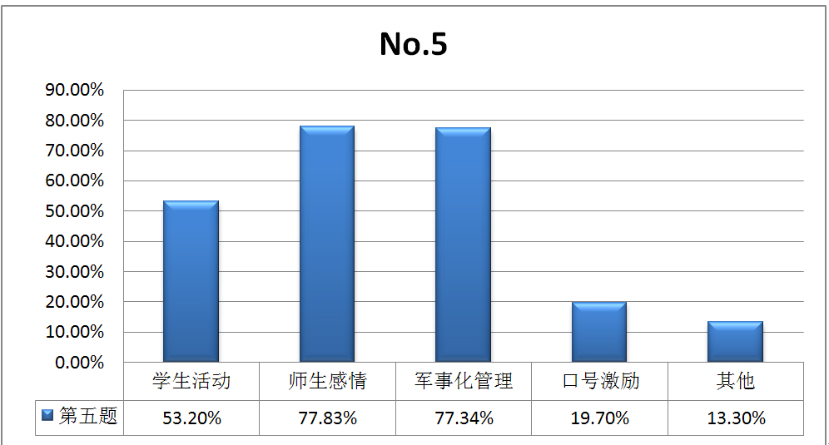
Student Activities Teacher-student Militarized Slogan others
Relationship Management Incentive

English Titles

Teachers play the most important role in students’ changing process. (The strict and effective militarized management can supervise and normalize students’ behaviors in this special context. )

Multiple Choices No.8 How do teachers encourage and help you?
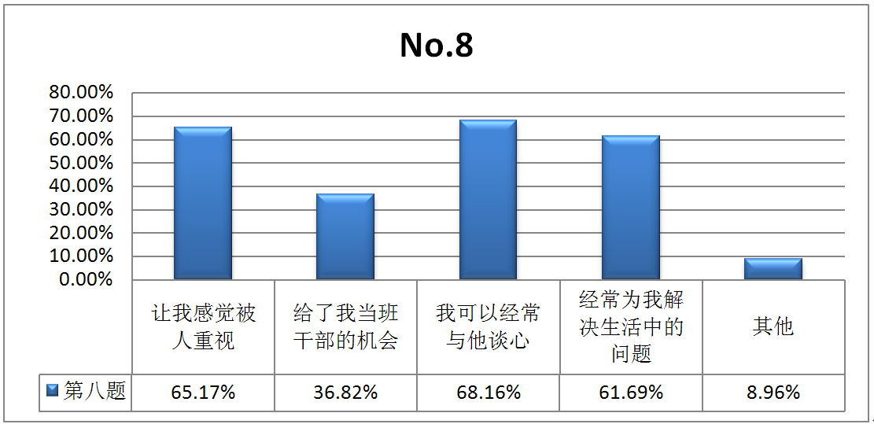
Let me feel Give me opportunity Heart-to-heart talk Help me others
appreciated to be student cadre at least solve private
thrice a week difficulties

English Titles

Second page : scale-measure topics
Point from NONE to VERY
1 2 3 4 5
No.1 Do you think you make progress after enrollment?
No.3 Do you think militarized management works on you?
No.6 Do you think teacher’s concern affect you?
No.7 Do you think student activities attract you?
No.8 Do you think slogan incentives affect you?

- Tests of Between-Subjects Effects
Dependent Variable: No.1 Independent Variables: No.3、6、7、8.
Null hypothesis ：Independent Variables have no effects to Depend Variable respectively and interactively.
Source | Type III Sum of Squares | df | Mean Square | F | Sig.
Corrected Model | 131.873(a) | 78 | 1.691 | 3.481 | .000
Intercept | 322.259 | 1 | 322.259 | 663.566 | .000
No.3 | 5.317 | 5 | 1.063 | 2.190 | .060
No.6 | 10.293 | 3 | 3.431 | 7.065 | .000
No.7 | 2.135 | 5 | .427 | .879 | .497
No.8 | 3.723 | 4 | .931 | 1.917 | .112
No.3 * No.6 | 1.416 | 4 | .354 | .729 | .574
No.3 * No.7 | 4.228 | 6 | .705 | 1.451 | .201
No.6 * No.7 | 6.868 | 6 | 1.145 | 2.357 | .035
No.3 * No.6 * No.7 | 1.826 | 3 | .609 | 1.253 | .294
No.3 * No.8 | 6.896 | 7 | .985 | 2.029 | .057
No.6 * No.8 | 4.459 | 6 | .743 | 1.530 | .174
No.3 * No.6 * No.8 | 1.062 | 2 | .531 | 1.093 | .338
No.7 * No.8 | 3.101 | 7 | .443 | .912 | .500
No.3 * No.7 * No.8 | .038 | 2 | .019 | .040 | .961
No.6 * No.7 * No.8 | .153 | 2 | .076 | .158 | .854
No.3 * No.6 * No.7 * No.8 | .000 | 0 | . | . | .
Error | 58.278 | 120 | .486
Total | 3479.000 | 199
Corrected Total | 190.151 | 198
- a R Squared = .694 (Adjusted R Squared = .494)
No.6: p=0.000 < 0.05------> reject Null hypothesis------>No.6 (teacher’s concern) has significant effect to No.1(student’s change).
No.6 * No.7: p=0.035 < 0.05------> reject Null hypothesis------->No.6 (teacher’s concern) and No.7 (student activities) interactively have significant effects to No.1(student’s change).

- Multiple Linear Regression Analysis
Dependent Variable: No.1 Independent Variables: No.3、6、7、8.

Coefficients(a)
Model |  | Unstandardized Coefficients |  | Standardized Coefficients | t | Sig. | 95% Confidence Interval for B |  | Collinearity Statistics
 |  | B | Std. Error | Beta | Lower  Bound | Upper  Bound | Tolerance | VIF | B | Std. Error
1 | (Constant) | 0.583 | 0.373 |  | 1.563 | 0.12 | -0.153 | 1.32
1 | No.3 | 0.211 | 0.064 | 0.224 | 3.316 | 0.001 | 0.086 | 0.34 | 0.724 | 1.381
1 | No.6 | 0.33 | 0.088 | 0.25 | 3.762 | 0 | 0.157 | 0.5 | 0.749 | 1.335
1 | No.7 | 0.181 | 0.065 | 0.203 | 2.781 | 0.006 | 0.053 | 0.31 | 0.619 | 1.616
1 | No.8 | 0.101 | 0.065 | 0.121 | 1.558 | 0.121 | -0.027 | 0.23 | 0.549 | 1.82
2 | (Constant) | 0.533 | 0.373 |  | 1.428 | 0.155 | -0.203 | 1.27
2 | No.3 | 0.238 | 0.062 | 0.252 | 3.858 | 0 | 0.116 | 0.36 | 0.78 | 1.283
2 | No.6 | 0.352 | 0.087 | 0.266 | 4.047 | 0 | 0.181 | 0.52 | 0.769 | 1.301
2 | No.7 | 0.232 | 0.056 | 0.261 | 4.139 | 0 | 0.122 | 0.34 | 0.835 | 1.197

Final regression equation : No.1 =0.533+0.238* No.3 +0.352* No.6+0.232* No.7
Weight comparison : teacher’s concern，0.352> militarized management，0.238> student activities，0.23

