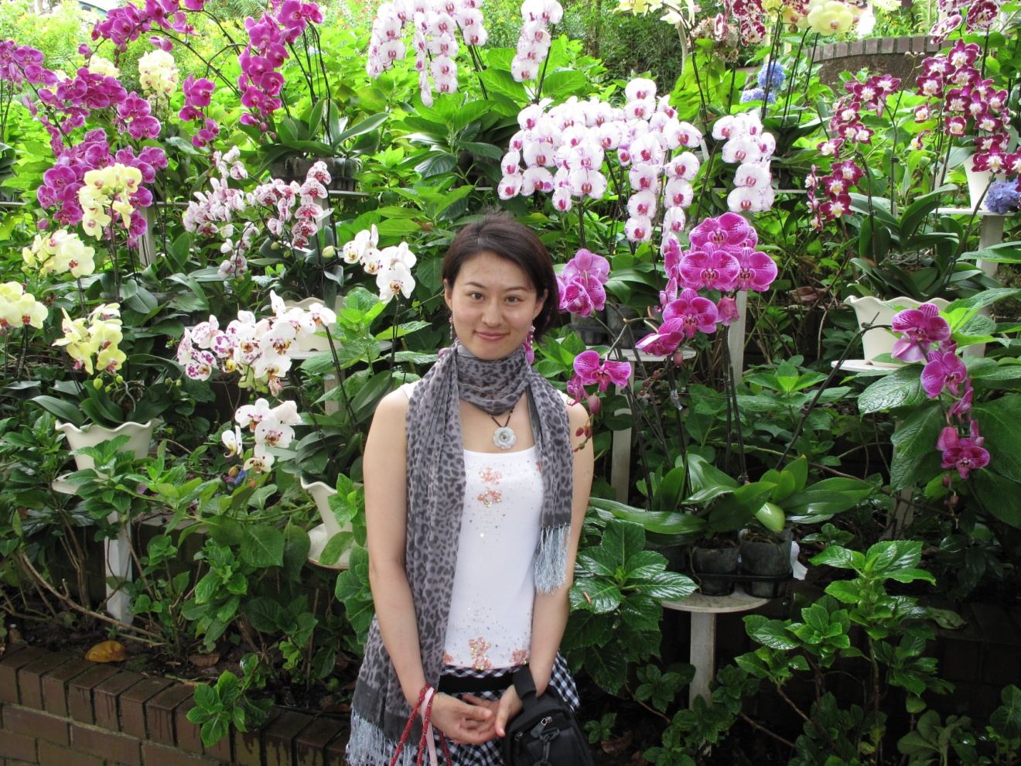

HI, everyone. I am a first year Ph.D student of NUS (National University of Singapore) Graduate School for integrative sciences and engineering. My research interests include but not limited to complex networks, systems biology and traditional Chinese medicine, in particularly the acupuncture. To my understanding, it may be understood from the context of complex networks.
I have been working in a highly inter-disciplined group under Prof. Li Baowen, who is one of the founding fathers of the emerging field “Phononics”. The group has about 30 members including visitors, postdocs, Ph.D students, undergraduate students and even high school students. They come from different background, such as physics, biology, electronic engineering, and material science and engineering … I really enjoy such academic atmosphere and it is why I am so enthusiastic to join Santa Fe’s summer school.
In the past two years, I have used the physics approach such as the concept of Anderson localization, structure entropy etc to study the dynamics of complex network. I hope I can work with people from different background to study a common interested problem from different approaches from this summer school, so that I will learn to look the same problem from different angles, and of course, I will see how my physics background can be used to solve other relevant problems.
In addition to research, I love to boil soup (included red beans, black beans.....) according to recipes from the traditional Chinese medicine. I am also very amazing about the foot reflexology.
I also like to play BADMINTON, YOGA, BELLY DANCE, reading novels, travel~~
Please don't hesitate to contact me☺: email: zhugm07@gmail.com

